Word Accessibility Remediation Guide
This guide provides instructions on how to ensure your Microsoft Word documents are accessible, covering built-in accessibility features and best practices for creating accessible content.

Accessibility Checker/Assistant
Microsoft Word includes a built-in Accessibility Checker to identify and help fix accessibility issues in your documents.

How to Use the Accessibility Checker
- Click on the Review Tab.
- Click on Check Accessibility > Check Accessibility.
- If this is your first time using the checker, an accessibility tab and toolbar will activate on the right side of the screen.
- The Accessibility Assistant will display a report showing issues or a "Looks Good! No issues" report on the right-hand side of the screen.
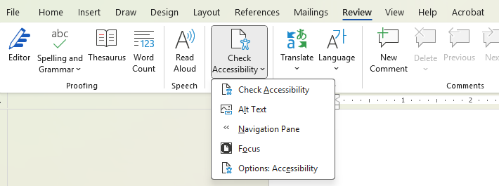

Common Accessibility Issues and Fixes

Missing Alt Text

Description
Images, charts, and other visual elements that convey meaningful information require alternative text (alt text) to describe their content for users who cannot see them. Decorative images should be marked as such.

How to Fix
- In the Accessibility Assistant, click on issues flagged under Media and Illustrations.
- Either approve the automatically generated description or create your own, then select "Approve" or "Mark as decorative."

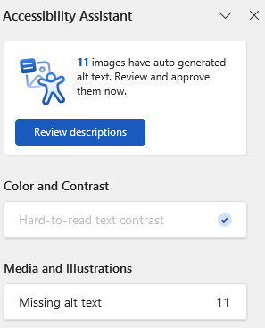
Tips/Notes
- You can also find this option by right-clicking on the image and selecting "View Alt Text."

Color and Contrast

Description
Sufficient color contrast between text and background ensures readability for users with visual impairments or color blindness.

How to Fix
- In the Accessibility Assistant, click on issues flagged under Color and Contrast.
- Click on a color suggestion of your choice to resolve the color contrast issue.
- The issue is resolved if there is a check mark beside the originally flagged issues.

Descriptive Links

Description
Links must have meaningful names that clearly describe their purpose, rather than generic text like "Click here."

How to Fix
- To edit the name of a link, right-click the link and select Edit Hyperlink.
- In the "Text to display" field, ensure an appropriate and meaningful name is entered.
- In the "Address" field, verify the correct URL is displayed.

File Name

Description
A descriptive filename allows screen reader users to quickly understand the document's content and purpose without having to open and explore it.

How to Fix
- To view the document name, go to File > Save As or Save as Copy.
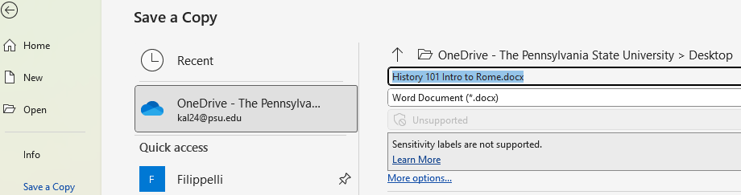
- Ensure the file name is descriptive (e.g., "History 101 Intro to Rome.docx" instead of "Document1.docx").

Tips/Notes
- The filename is often the first piece of information encountered by a screen reader when navigating a document.

Languages

Description
Setting the document language ensures that screen readers can correctly pronounce the text and apply appropriate linguistic rules.

How to Fix
- To set the language, go to Review > Language > Set Proofing Language.
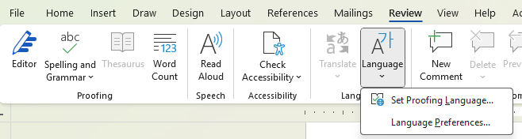
- Highlight the language you want to change and select the appropriate language, then click OK.

Tables

Description
Accessible tables ensure that screen readers can logically interpret the table structure and data relationships.

How to Fix
- Avoid Merged and Split Cells: Merged or split cells disrupt the logical flow of data for screen readers and can make navigation difficult for keyboard users. If possible, consider presenting data in other ways (e.g., paragraphs with headings).
- Designate a table header row or column:
- Click anywhere in the table.
- Go to the Design tab at the top of the page (ensure it's the one under TABLE TOOLS or Table Design).
- Check the Header Row checkbox for the first column and/or first row.
- Type (or retype) your column headings.

Tips/Notes
- This setting needs to be check marked for every table. You can also right-click on the table and go to Table Properties > Row > Repeat as header row at the top of each page.

Headings

Description
Headings explain what a document section is about and provide structure. Using built-in heading styles and descriptive heading texts makes it easier for screen reader users to navigate the document.

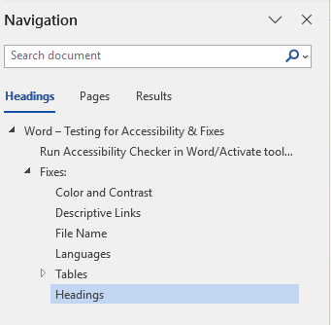
How to Fix
- Open the Navigation pane by holding Ctrl + F and selecting the Headings tab (or Home > Styles). All heading styles used in the document will be listed in chronological order.
- If the document needs headings and subheadings added, open the Styles Pane (the diagonal down-pointing arrow on the Home tab) to add or edit heading styles.
- Start with Heading 1 for the main title of your document.
- Use Heading 2 for main sections, Heading 3 for subsections, and so on. Always follow a logical hierarchy and avoid skipping heading levels.

